**DIPLOMA IN COMPUTER SCIENCE**

**SCHOOL OF COMPUTING**

|  |
| --- |
| **Assessment: Project** |

|  |  |
| --- | --- |
| **Course Code:** | **DCS1003** |
| **Course Name:** | **Information Technology & Application** |
| **Academic Session:** | **September 2023** |
| **Lecturer’s Name:** | **Ms Teo Choon Yeh** |

|  |  |
| --- | --- |
| **Release Date:** | **30th October 2023** |
| **Submission Due Date:** | **30th November 2023** |

|  |  |  |  |
| --- | --- | --- | --- |
| **Weightage (%):** | **100** | **Marks Obtained:** | **100** |

**Student’s Declaration**

I certify that this assignment is my own work, and appropriately acknowledged wherever material adapted from other sources. I understand that plagiarism, cheating, collusion, fraud, fabrication or falsifications of data are not acceptable. I agree that if at any time it is shown that I have significantly misrepresented material submitted to Crescendo International College, any marks or credits awarded to me on the basis of that material may be revoked.

|  |  |  |  |
| --- | --- | --- | --- |
| Student Name | KISHOKKUMAR A/L MUNIANDY | Student ID | MCDCS2309292 |
| Signature |  | Date | 6/11/2023 |

Table of Contents

Introduction 3

Whats the difference between xml and html? 4

Other differences between xml and html! 4

Typing 4

Schema 5

When should use html vs xml? 6

How to use html and xml together 7

What is xml? 8

What is html? 10

PICTURE OF XML FILE 11

PICTURE OF HTML CODING 12

PICTURE OF WEB PAGE ,XML IN HTML AND LINK. 13

Conclusion 14

Reference list 14

## Introduction

Html and xml are related to each other, where html displays data and describes the structure of a webpage, whereas xml stores and transfers data. html is a simple predefined language, while xml is a standard language that defines other languages. Web developers also use xml to define the structure and content of html documents. xml is used as the underlying markup language for xhtml (Extensible Hypertext Markup Language), which is a stricter and more structured version of html. xml is also used in web development for data storage and retrieval.

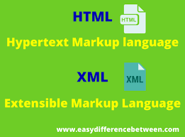

## Whats the difference between xml and html?

The difference between html and xml is that html is a markup language used to create web pages, while xml is a markup language used to store and transport data. html focuses on the presentation of data on web pages, whereas xml focuses on describing the data itself. xml is important because it allows data to be shared and processed across different systems, while Html is important because it provides the structure and formatting for web content that can be displayed in a web browser.

## Other differences between xml and html!

Despite their similarities of xml and html have several differences. Objective html is commonly known as the language of the web. html’s primary purpose is to display content, given in a text-based document, in a graphical form in the browser.

In contrast, xml allows different applications to exchange and store data and its structure in a way that is universally understood. The primary purpose of xml is to allow different types of applications, such as databases, to understand and use the same data and its structure.

## Typing

html uses dynamic typing, where attribute types are checked at runtime against the expected data type. For example, if an attribute is expected to be a number but is input as a string, it may cause an error or unexpected behaviour of webpages at runtime. Dynamic typing allows for changes to webpages with new incoming data.

In contrast, xml uses static typing, where attribute types are predefined in an xml schema and checked before compiling or processing. Static typing leads to fewer errors but also less dynamic content.

## Schema

Document type definitions (DTDs) or schemas provide a structure that can be validated and repeated for similar documents. They typically include information like this:

The html or xml version being used

Allowed elements and attributes

Rules for document structure and element relationships

In html the dtd is a declaration included at the beginning of an html document.

In xml the dtd is a separate file. The dtd is more important in xml because xml tags are defined by the document creator. The dtd contributes to the shared understanding of the tags between the data sender and receiver.

## When should use html vs xml?

Html is a type of markup known as a presentation language. The name presentation language is due to the fact it is for display purposes. You use Html to create webpages and client-side web applications. It’s typically combined with Cascading Style Sheets (css) for styling purposes and the JavaScript programming language for dynamic behaviours. In contrast, you use xml for the exchange of data between two applications or systems. To understand the same format, the applications have shared xml schemas that define the content of an xml file.

## How to use html and xml together

Xml can be embedded in html and parsed with the JavaScript programming language to create webpages that are dynamic. Similarly, html can also be embedded in xml if necessary, using character data (CDATA) for plaintext. See the following examples.

## What is xml?

*Xml stands for extensible Markup Language

*Xml is markup language much like Html

*Xml was designed to store and transport data

*Xml was designed to be self-descriptive

*Xml is W3c Recommendation

How does xml work?

xml data format works by using tags to identify different types of data and define structure of stored data

Xml is not a programming language. It is a markup language used to describe the structure and content of data but does not contain instructions for the computer to execute like a programming language does. The application’s developer defines the xml tags to describe the data in an application-specific way. In the above example, the xml starts with a person tag followed by name, age, and job tags. This data could belong to a social media app, for example.

Xml Does Not Use Predefined Tags

The xml language has no predefined tags.

The tags in the example above (like <to> and <from>) are not defined in any xml standard. These tags are "invented" by the author of the xml document.html works with predefined tags like <p>, <h1>, <table>, etc.

With xml, the author must define both the tags and the document structure.

Xml is Extensible

Most xml applications will work as expected even if new data is added (or removed).

Imagine an application designed to display the original version of note.xml (<to> <from> <heading> <body>).

Then imagine a newer version of note.xml with added <date> and <hour> elements, and a removed <heading>.

The way xml is constructed, older version of the application can still work:

## What is html?

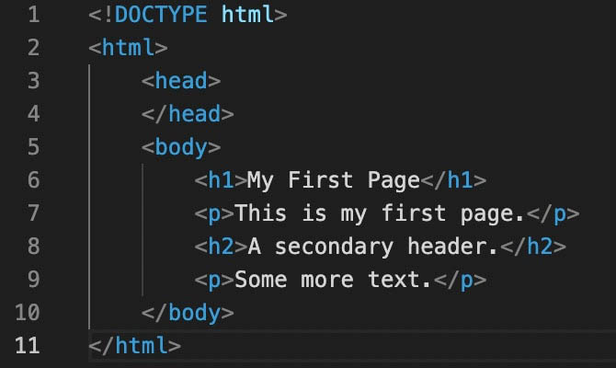Html is used to create web pages and display content on the World Wide Web. It consists of a set of tags and attributes that are used to structure and format text, images, videos, and other types of media. html provides a way for developers to create content that can be rendered by web browsers, allowing users to view and interact with web pages. Its a fundamental technology for building websites and is often used in conjunction with other technologies such as css and javascript. A web page is not created using a single language it is created using many languages, technologies, and programs and html is one of them it is widely used by programmers to understand the difference between html and xml.

## PICTURE OF XML FILE

## PICTURE OF HTML CODING

## PICTURE OF WEB PAGE ,XML IN HTML AND LINK.

http://localhost/New%20folder/LAPTOP%20COLLECTIONS.html

## Conclusion

Html is commonly known as the language of the web. Html's primary purpose is to display content, given in a text-based document, in a graphical form in the browser. In contrast, xml allows different applications to exchange and store data and its structure in a way that is universally understood. Xml may sound like bad news for programmers of all levels. However, as daunting as it initially appears. Xml is a convenient tool for web developers who want to write high-quality code in terms of functionality, security, and performance. Invest time in practice, just like any other programming language, while learning xml to master it rapidly.

I create a table web page by using td,tr basic code from html. And it is a very simple method to make a table by link xml into html.

## Reference list

[https://byjus.com/free-ias-prep/difference-between-xml-and- html/https://codeinstitute.net/global/blog/what-is-xml/](https://byjus.com/free-ias-prep/difference-between-xml-and-%20%20html/https://codeinstitute.net/global/blog/what-is-xml/) (pg 9)